Crawford County Career and Technical Center
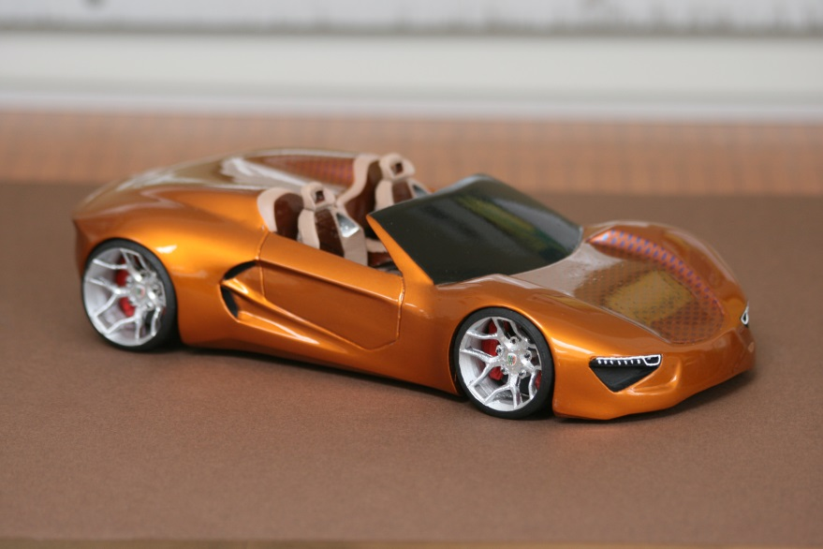
Solar Powered Sports Car Created by Crawford County CTC Student
John Brown – Drafting and Design Instructor
The Crawford County CTC Program is a 3 year program. We have students in grades 10 through 12. On average we have around 25 students combined in each of the three years.
John O’Laughlin is one of the students in the CTC Program John has done some outstanding work in the program. One of his best projects was to model the Proton (convertible) seen above. The project spanned three of our shops; including Drafting, Commercial Art, and Auto Collision.
The idea was to design a car for the Cleveland 2D3D contest. John would be entering the industrial design category for this project. The basis of the idea was a solar-assisted plug-in electric powered sports car that is completely emissions free and also very cool to look at. John decided to call the car the "Proton EV" since it deals with electricity, protons and such. He started by sketching out the design on several sheets of paper in order to get a good idea of what he wanted before he got to the computer. “The 3D software I used is called Modo, I used Modo 601 to model the car which took around 2 weeks.” John said. After modeling the car in Modo, John used several different programs like Meshlab and Autodesk inventor in order to get the car into a printing state. He separated the seats, steering wheel, mirrors, and wheels from the car to be printed separately. The car model was a process that took a very long time. He used icing body filler to fill in the steps between the plastic and sanded it down until the surface was continuous. Next, John primed it and wet sanded the primer a few times. It was later coated with automotive primer. After that, the autobody teacher at the career and technical center sprayed it with metallic orange and harlequin blue-purple paint. The small details John brush painted with an extremely fine paint brush and enamel model paints (It took a while to get the details) Lastly, John glued the parts onto the car and applied the logos. According to John, the Dimension 3D printer is great for something like this, it perfectly replicated his model and brought his car to life. “It's a joy to see my creation in the real world.” said John. John is also working on another project now. The red car is called the "Hydrus". John designed it in 9th grade and is working to make it look more realistic. “I'm thinking I might try to print this one as well and give it the full treatment like the Proton 3D print.” John said. “Just for fun, here's a link to the animation I made of my Proton EV convertible - http://vimeo.com/85482290 It should give you a better idea of how the car is shaped and the little details.” he added.

One other project worth mentioning is the Zero Trim Solar Lawn Mower, a design that John won a $40,000 scholarship for last year. It was also 3D printed. He entered it in the Cleveland 2D3D Contest and ended up winning the category. “The Proton only won the juror's special merit, even though I think more thought went into it.” John said.
Not all students have the ability to visualize three dimensional objects easily. Being able to print an object and have the student able to hold the part and turn it to see the relationship of surfaces and features provides a whole new teaching tool for bringing students up to speed with a difficult to teach ability.
“In our program, we use the Stratasys Dimension SST 1200es for prototyping parts as well as building models for about everyone who could need it.” Said Instructor John Brown. So far they have built models for the following programs:
- Drafting and Design
- Precision Machining
- Commercial Art
- Welding
- Electronics
- Diesel Mechanics
- Auto Collision

They have even built parts for our buildings maintenance department for repairs in our facility. The class is finding new ways to use the 3D printer as a teaching tool every day.
“One of the benefits of partnering with Allegheny Educational Systems to purchase and install the Stratasys Dimension SST1200es is that we have seen an increase in enrollment due to the modernization of our program. Students are also excited to be working with equipment considered cutting edge in our area. We are also seeing local companies who have the same or similar models of 3D printers. This could allow entry level positions in companies from the student’s experience with the 3D printing technology.” said John Brown.
For more information contact:
John Brown, Drafting and Design Instructor
Crawford County Career and Technical Center
860 Thurston Road
Meadville, PA 16335
814-724-6024 x227
drafting@crawfordctc.org

