Lehigh University Students Learn About Small Scale Manufacturing With 3D Printing
BY SCOTT J GRUNEWALD ON TUE, APRIL 29, 2014 · 3D PRINTING,PROTOTYPING, VIDEOS

A little while back Stratasys released a White Paper on injection molding using its Objet line of printers to 3D print the molds. The professors at Lehigh University decided to have their students put that process to the test. They ended up with a plastic car and a very real method for manufacturing on the small scale for niche markets.
In this video, director of Wilbur Power House and Design Labs at Lehigh University, Brian Slocum, walks us through testing the process of creating molds from polymer resins.
In order to put the process to the test, the students repurposed a project from one of their mechanical engineering classes. They were tasked with designing small matchbox sized race-cars and then using their design to create a workable mold. Traditionally this mold would be made using a CNC mill to tool it from a solid piece of aluminum; however, for this project they used an Objet30 Pro photopolymer 3D printer to print the molds.
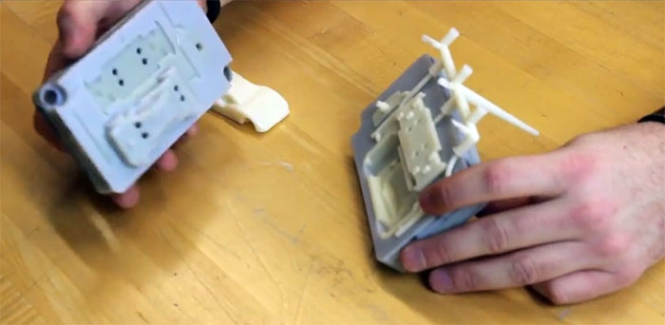
Lehigh students discovered that when it comes to using 3D printed molds for injection mold manufacturing, Stratasys is not over-selling the process. Within a matter of hours students went from car and mold model to useable injection mold, a process that usually takes days or even weeks. While molds printed with Polyjet machines are not currently capable of being used as often as molds created using traditional milling techniques and materials, they are ideal for rapid prototyping and small scale manufacturing, as clearly evidenced by this cost comparison between traditional aluminum molds and 3D printed polymer molds.

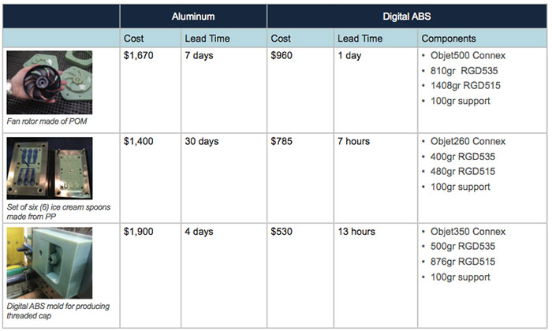
While tooling an aluminum mold will give you significantly more injections, it won’t matter if you don’t need to make 20,000 copies of a single item. If you only need to make a few hundred or a few thousand copies, not only will 3D printed molds save you time and money, two things that new businesses are often short of, but they will allow you to change and evolve your design relatively quickly with very little added cost or delay. This will dramatically reduce the cost of taking your products to market and reduce the required cost for your buyers to purchase it.
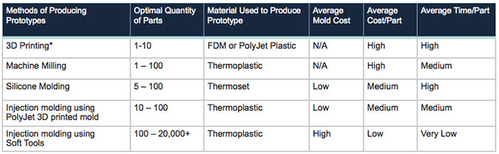
For good or ill, Capitalism has become the single most influential concept of our time and it informs virtually every aspect of our lives. While it is billed as a level playing field that anyone can use, money has always been the invisible gatekeeper that blocks access to these ostensibly open markets. Whether this is an intentional situation created by people unwilling to share, or simply a side effect of living within a societal structure that uses profit and success as a motivator is a debate for another time. But what isn’t debatable is the fact that you simply have to be able to afford to buy in, and using traditional methods for doing so has become considerably more expensive.
The promise of 3D printing was never just about makers and hobbyists replacing knobs on appliances or printing Yoda busts, it was always about removing the economic barriers that divide those who can manufacture from those who cannot. It doesn’t so much replace money, as just change the way that you use it and the amount required to make more of it. This niche manufacturing process is viable now with the current generation of printers and polymers. When you think of the massive leaps in quality that 3D printers have made in just the short time they have been around, just imagine where they will be in another year or two and how 3D printed injection molds may be used.
Learn more about the injection molding process by reading the White Paper here,

